**Manual Test Plan - Tank Battle 2.0**

**Week 0:**

**1. StartPage**

Navigating to “/” route. Start Page is displayed where the user can choose to either start a new game or join an existing game with just other player.

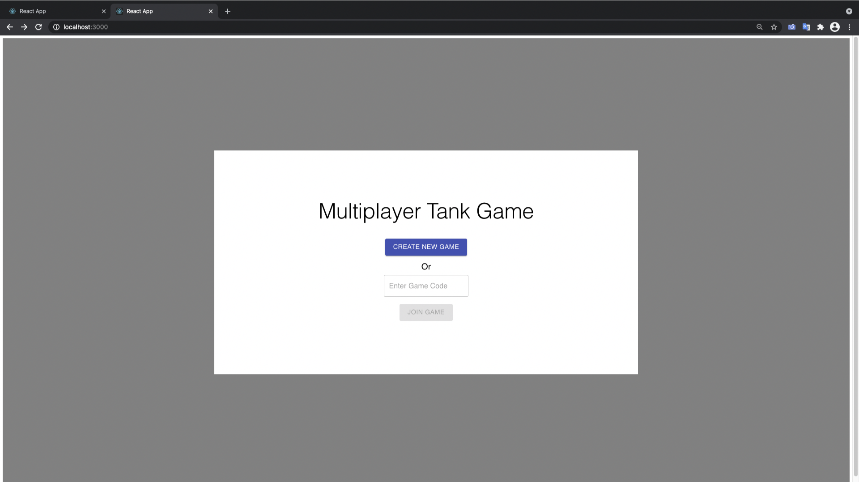

**2. CreateNewGame**

Click on the “Create New Game” button in the Start Page

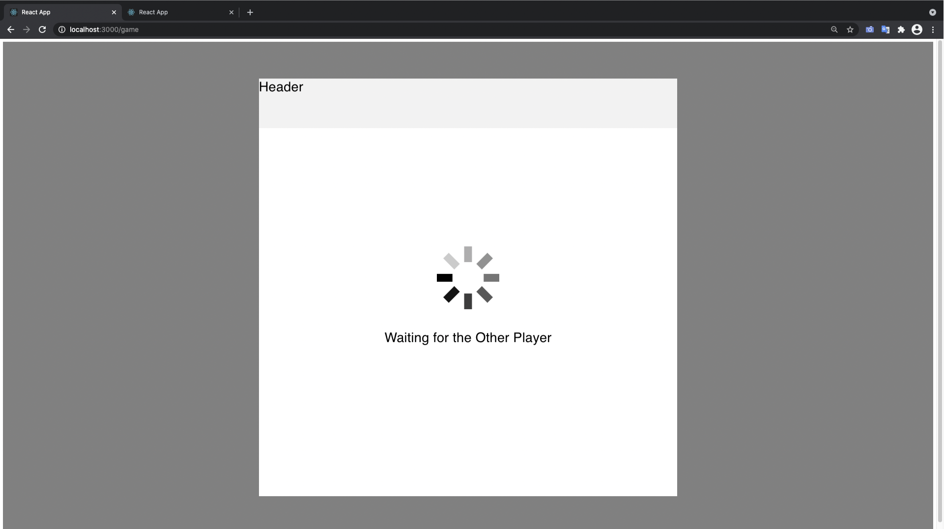

It takes the user to the Game Page and waits for the second player to join

**3. JoinGame**

Click on the “Join Game” button in the Start Page.

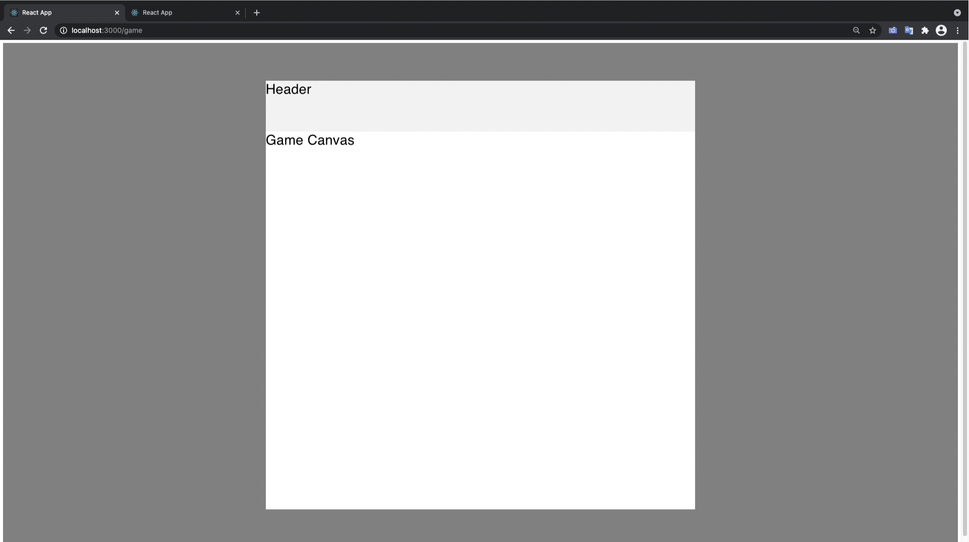

It Takes the User to Game Player and loads the Game canvas

**Week 1:**

**4. Join Game**

Now After both players join the game room. Two tanks one controlled by either player are displayed

**5. Move Player**

Arrow buttons lets the user move the tanks across the screen

**6. Movement is visible in both Players screen**

Moving a player changes the player position on both windows



**7. Player Fires Bullets**

Pressing the space bar lets the user fire bullets towards the enemy

**8. Player Bullets are visible on both Screens**

Fired Bullets are visible on both screens

